The following are the task flows of the mobile application that were dealing with:
The flows will use the previous other information which was provided in personas, requirements, and user-journey.

Task Flow 1: Auto-Reschedule Missed Task (Alex)

Detects a missed study block and lets the user auto-reschedule it to the next available slot or preserve it for manual review.
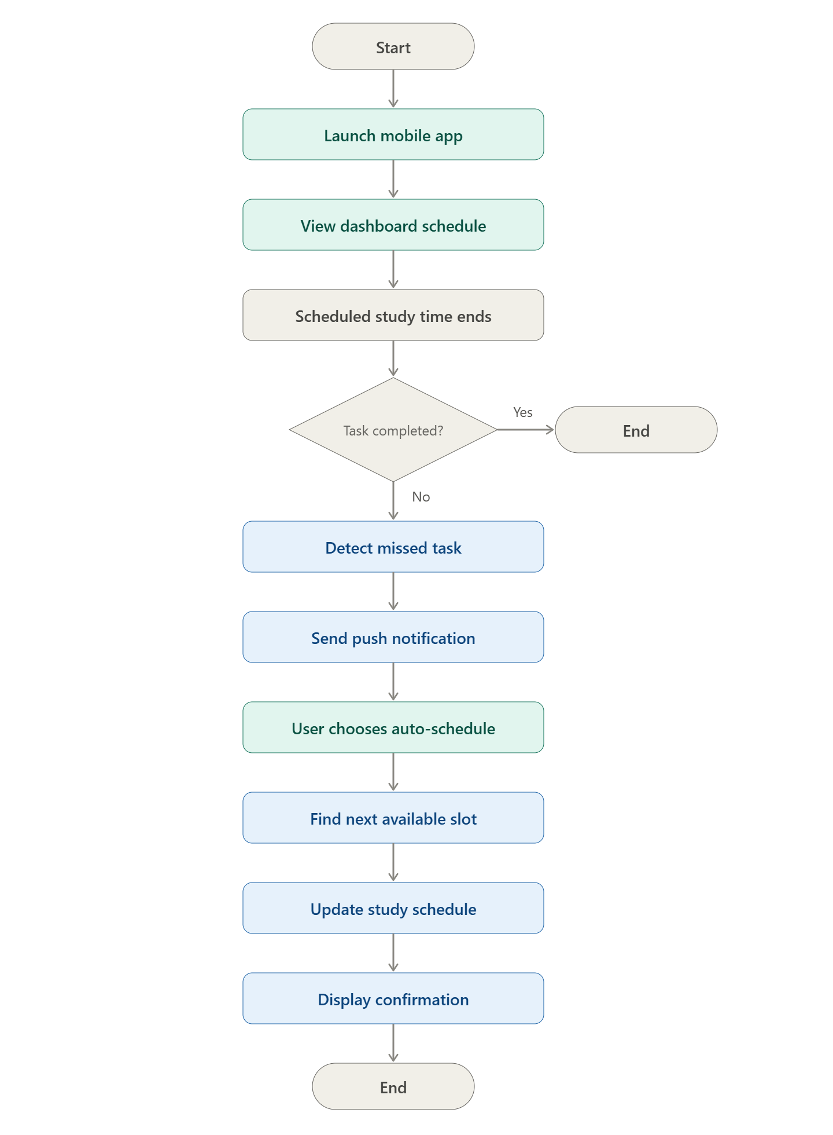

Task Flow 2: Add Academic Task (David)
Lets a user add a new task with title, course, deadline, priority, and duration, then confirms it's added to the schedule.
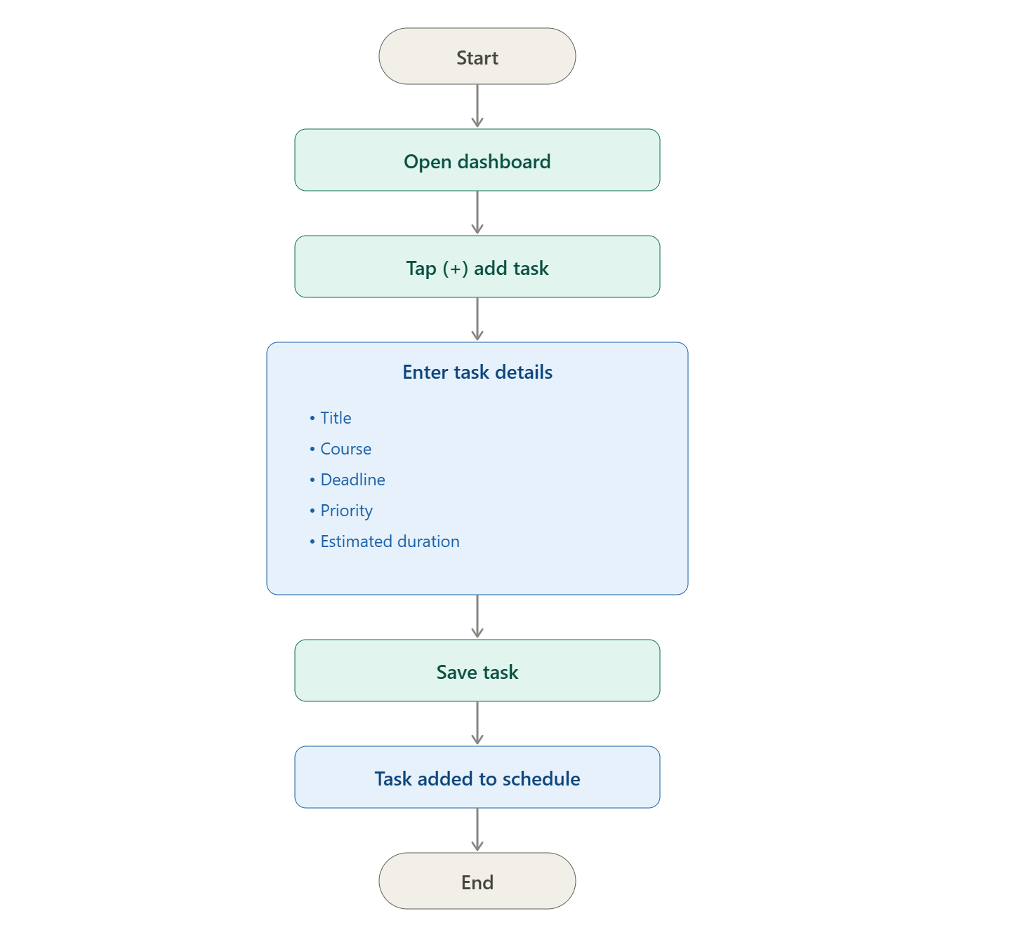

Task Flow 3: Set Unavailable Time (Brenda)
Logs a shift or unavailability window and automatically recalculates the study schedule around it.
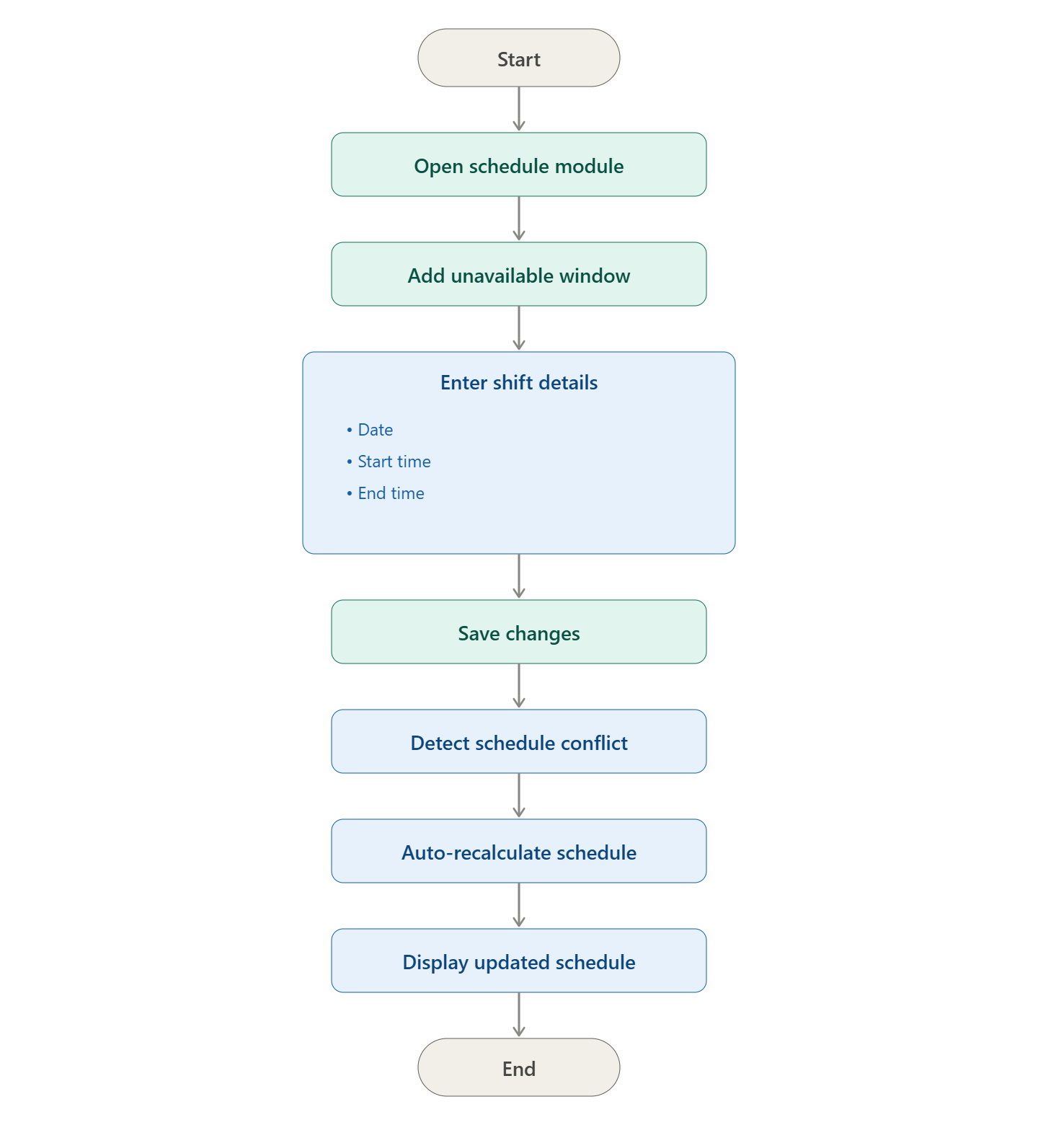

Task Flow 4: Complete Task (David)

Lets a user select and swipe-complete a study session, updating progress and showing success feedback.
